Craftsman 572610530 Rotary Tool Parts
PA6 GA33

Dremel Brushes 90930-05
Fits 100, 200, 275, 285, 300, 395, 595 Types 3,4,5,6,600 Types 1 & 2
We Sell Only Genuine Craftsman ® Parts.

Bearings are on the armature

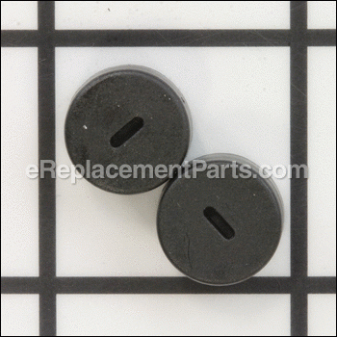 | Caps Pair  Part Number: 2615302217  In Stock, 1 Available | $3.99

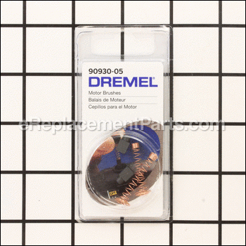 | Brush  Part Number: 90930-05  In Stock, 5 Available | $10.18
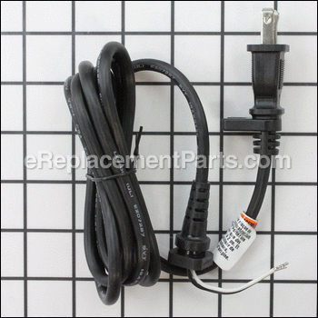 | Cord  Part Number: 2615294041  In Stock, 2 Available | $6.99
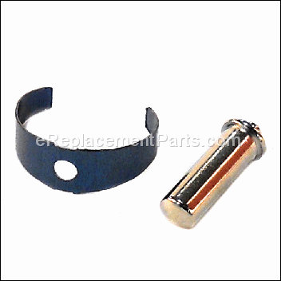 | Lockspring  Part Number: 2615297356  Ships In 11 - 17 Business Days | $3.99
 | Man, Own  Part Number: 2615302557  Ships In 11 - 17 Business Days | $2.53
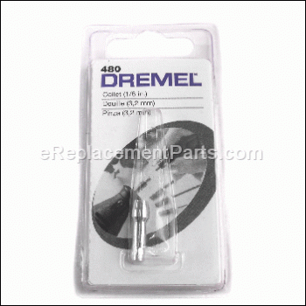 | Collet  Part Number: 2615000480  Backorder: No ETA. | $5.29

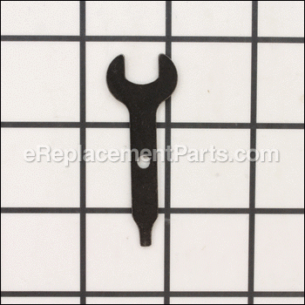 | Wrench  No Longer Available [ More Info ]  Part Number: 990962  Discontinued | Sorry, this part is no longer available
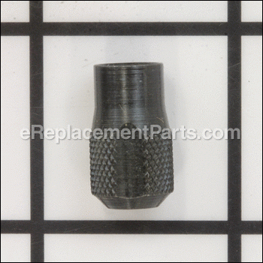 | Collet Nut  No Longer Available [ More Info ]  Part Number: 2615297355  Discontinued | Sorry, this part is no longer available
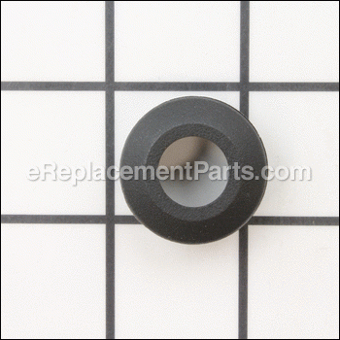 | Hsning Cap  No Longer Available [ More Info ]  Part Number: 2610925247  Discontinued | Sorry, this part is no longer available
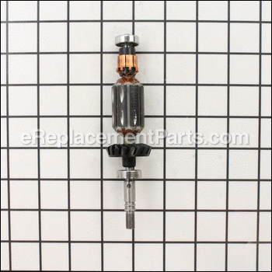 | Armature  No Longer Available [ More Info ]  Part Number: 2610941200  Discontinued | Sorry, this part is no longer available
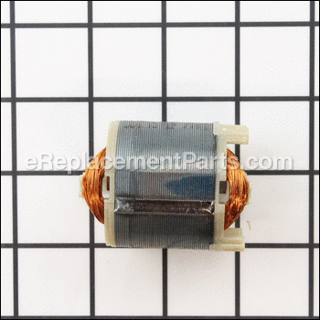 | Field Assy  No Longer Available [ More Info ]  Part Number: 2615302206  Discontinued | Sorry, this part is no longer available
 | Housing Set  No Longer Available [ More Info ]  Part Number: 2615297374  Discontinued | Sorry, this part is no longer available
 | Housing Set  No Longer Available [ More Info ]  Part Number: 2615297374  Discontinued | Sorry, this part is no longer available
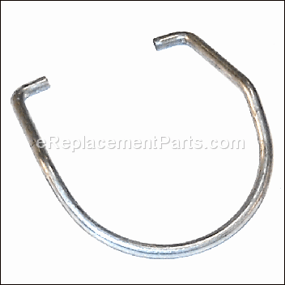 | Hanger  No Longer Available [ More Info ]  Part Number: 2615294043  Discontinued | Sorry, this part is no longer available
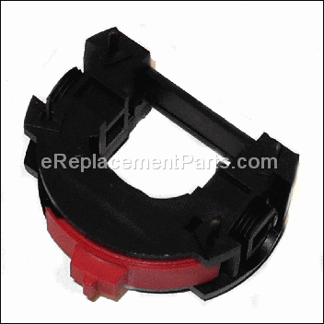 | Switch  No Longer Available [ More Info ]  Part Number: 2615294890  Discontinued | Sorry, this part is no longer available
 | Switch  No Longer Available [ More Info ]  Part Number: 2615294890  Discontinued | Sorry, this part is no longer available
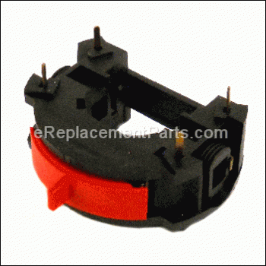 | Switch  No Longer Available [ More Info ]  Part Number: 2615294889  Discontinued | Sorry, this part is no longer available
 | Screws  No Longer Available [ More Info ]  Part Number: 2615302205  Discontinued | Sorry, this part is no longer available
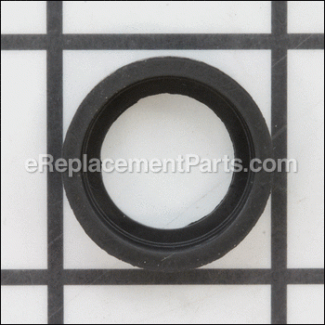 | Sleeve  No Longer Available [ More Info ]  Part Number: 2615297373  Discontinued | Sorry, this part is no longer available

